MegaWizard Plug-In Manager

- To start creating the memory module, go to Tools -> MegaWizard Plug-In Manager. And click on “Create a new custom megafunction variation” as shown in Fig 1. Then click Next.

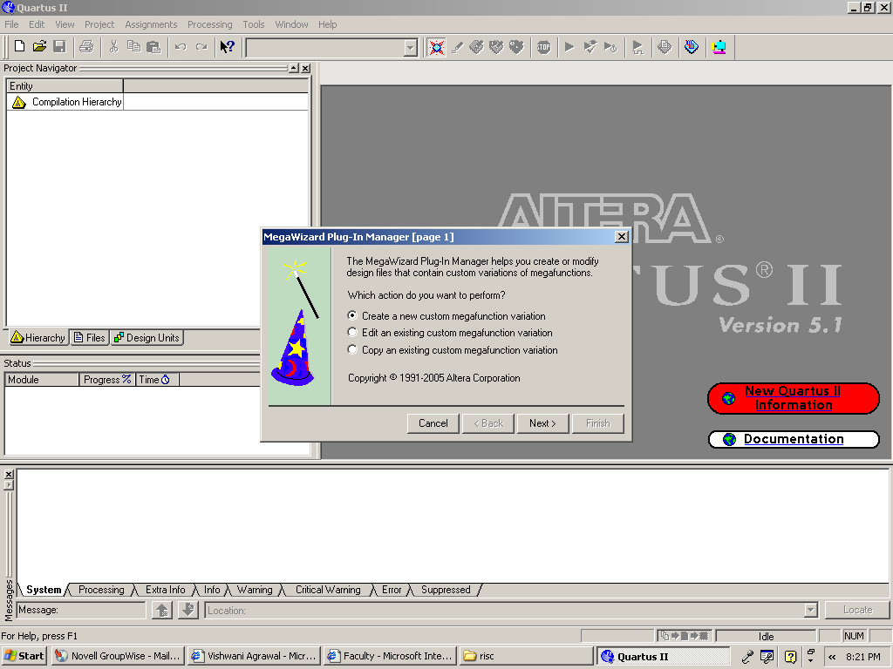
Fig. 1

- On the 2nd page select the device family “Cyclone II”. On the left hand side under the name memory compilers choose RAM: 1-PORT module as shown in the Fig 2. Type of output file that needs to be selected is VHDL. And finally name your output file. Then click Next.

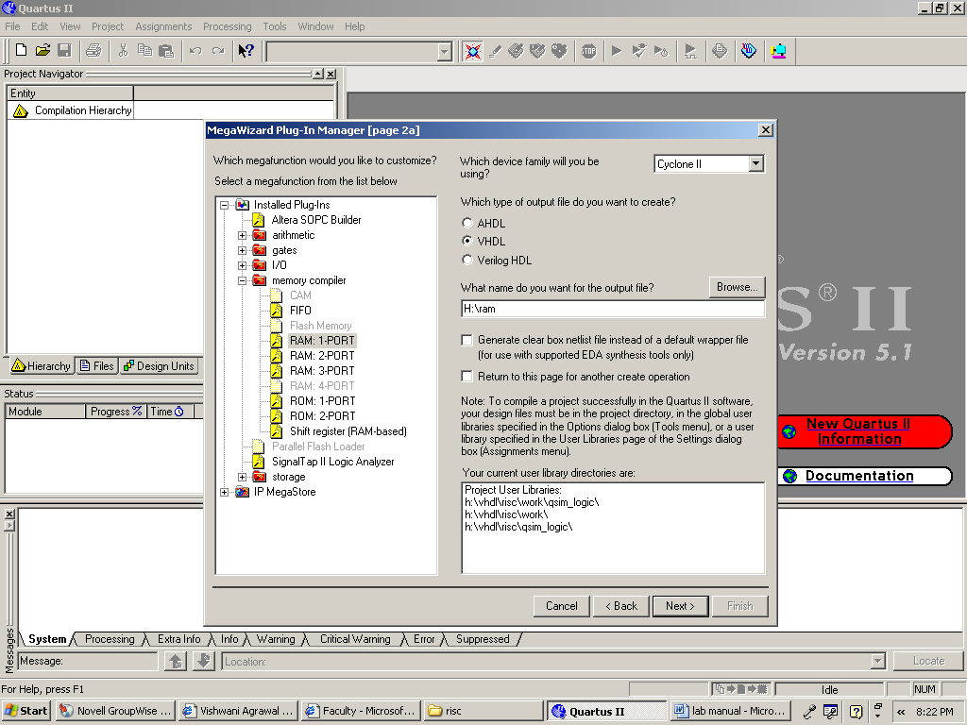
Fig. 2

- On page 3, ‘q’ output bus should be made 16 bits wide and the number of words should be selected as 8192 as shown in the Fig. 3. Then click “Next”.

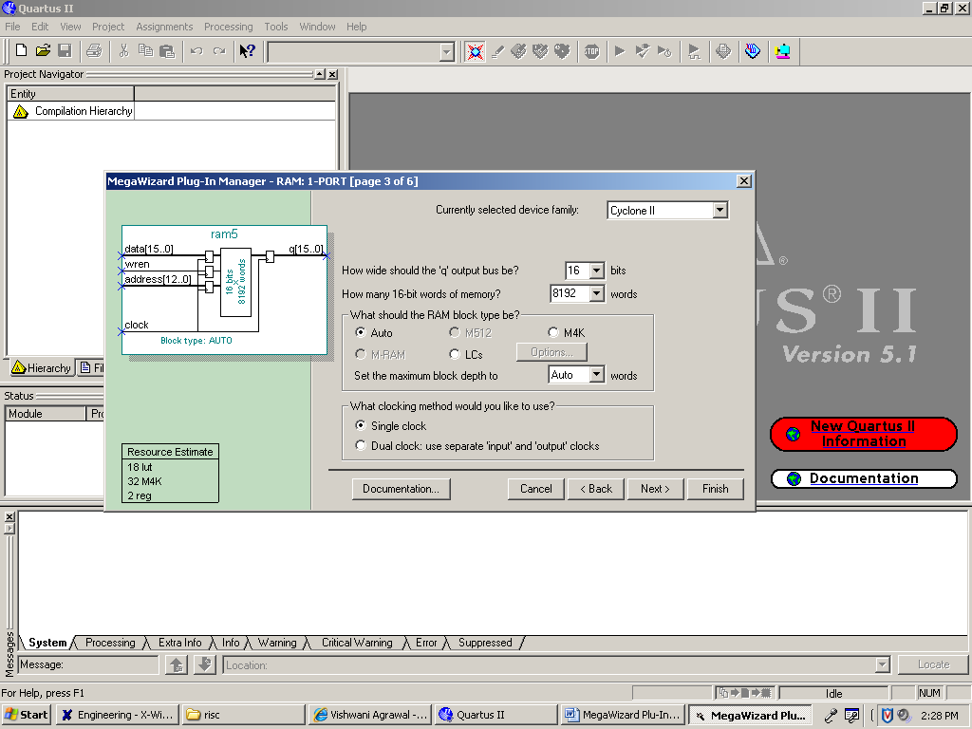
Fig. 3

- Page 4 will appear as shown in Fig 4 . Uncheck ‘q’ output port . Click Next.

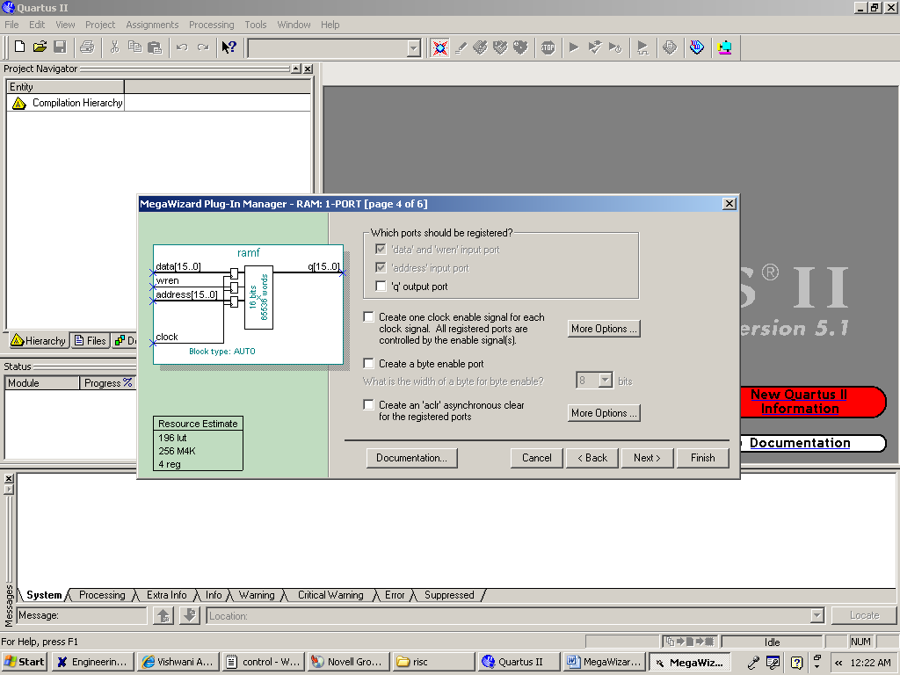
Fig. 4

- To place processor instructions into the memory, you need to specify initial values that should be stored in the memory once your circuit has been programmed into the FPGA chip. This can be done by telling the wizard to initialize the memory using the contents of a memory initialization file (MIF). I have specified a file named RAM_init.mif, which then has to be saved in the directory that contains the Quartus II project. MIF format is given to you. Write your MIF File as shown in that format. And click on “Yes, use this file for memory content data” and add your RAM_init.mif file as shown in Fig. 5. Then click Next.

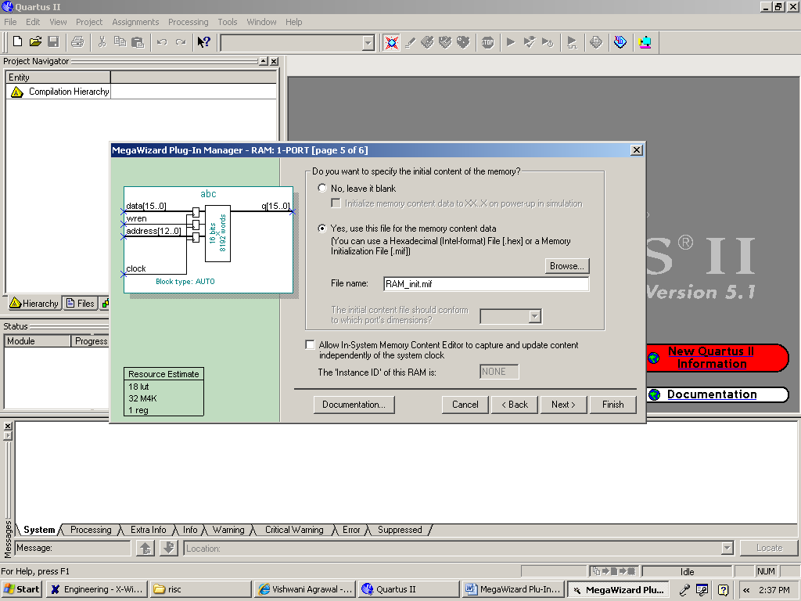
Fig. 5

- Finally your .vhd file for RAM module will be created in your working directory.

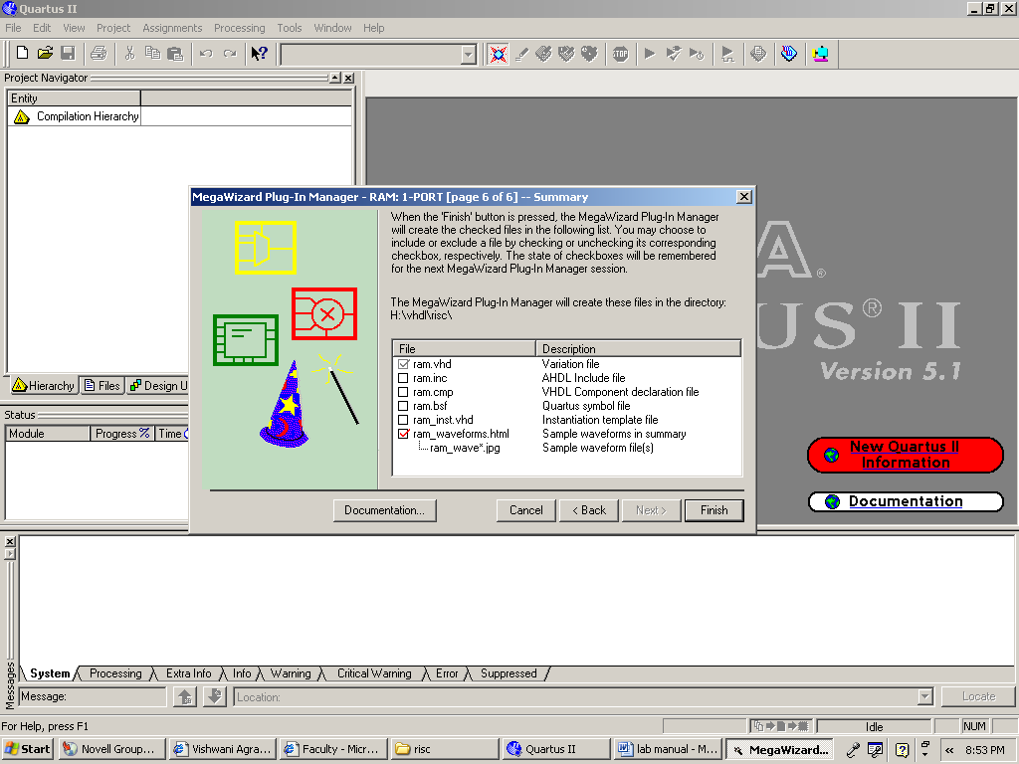
Fig. 6

